Database reporting

Name of student

Name of professor

University

Course

Date

Creating tables;

CREATE TABLE EMOLOYEES

(

EMPLOYEE_ID INT,

SSN VARCHAR(255),

FNAME VARCHAR(255),

LNAME VARCHAR(255),

POSITION VARCHAR(255),

SALARY INT,

PHONENUM VARCHAR(255)

)

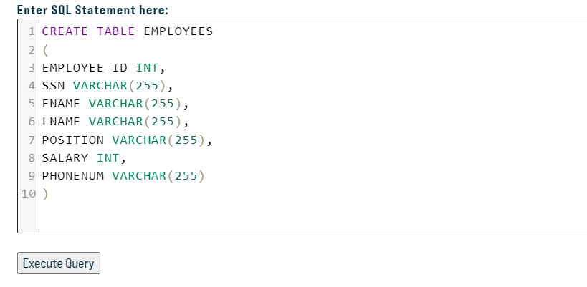

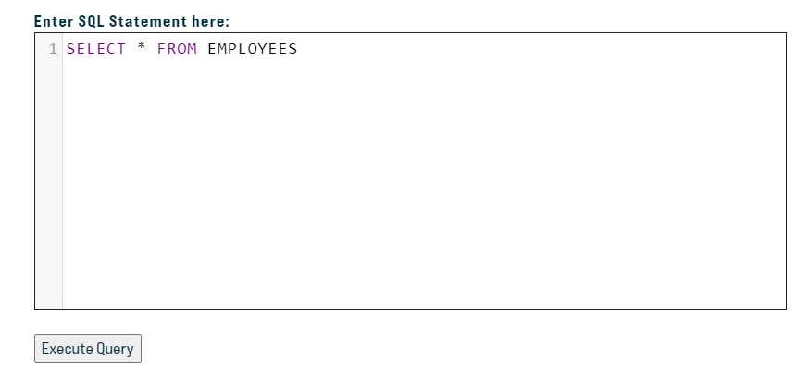

INSERT INTO EMPLOYEES(EMPLOYEE_ID,SSN,FNAME,LNAME,POSITION,SALARY,PHONENUM)

VALUES

('100','111-11-0607', 'John','Smith', 'Manager', '35000.75', '800-350-0000'),

('200','333-22-0607','John','Jones','Associate','25000.00','202-999-0000'),

('300','444-44-0607','Sally','Smith','Manager','46500.00','303-999-0000')

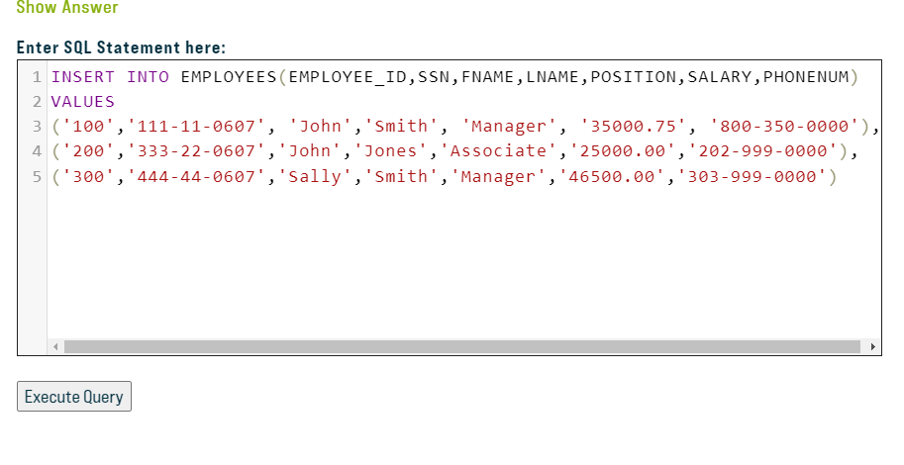

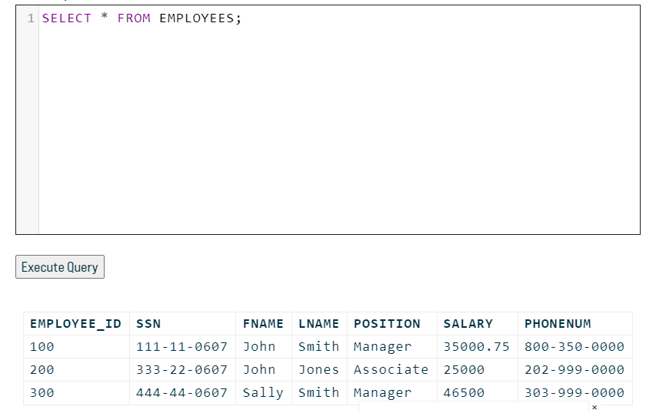

INSERT INTO EMPLOYEES(EMPLOYEE_ID,SSN,FNAME,LNAME,POSITION,SALARY,PHONENUM)

VALUES

('500','111-23-0607','Samaria','Alexis','Developer','36900', '800-571-0000')

**Task 3**

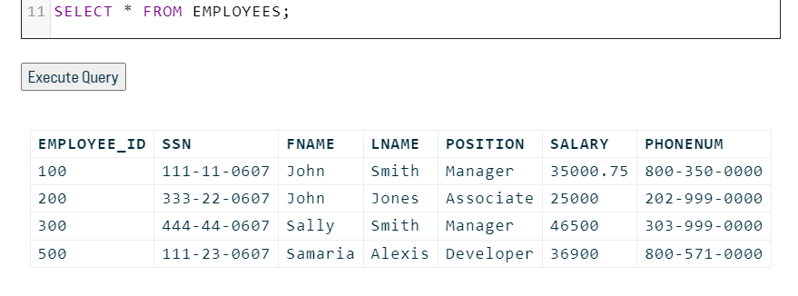

**Task 4**

SELECT EMPLOYEE_ID, FNAME,LNAME,POSITION,SALARY FROM EMPLOYEES;

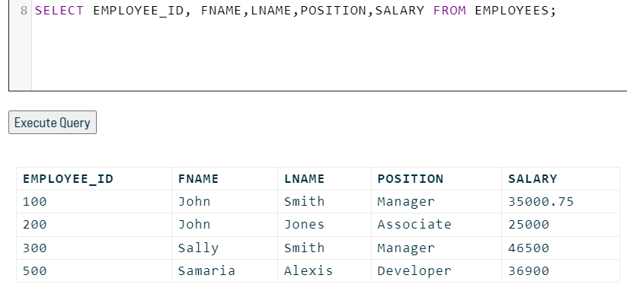

**TASK 5**

SELECT EMPLOYEE_ID, FNAME,LNAME,POSITION,SALARY,PHONENUM FROM EMPLOYEES

WHERE SALARY >20000

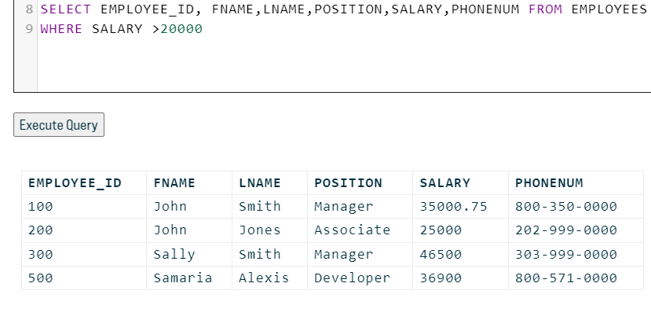

**TASK 6**

SELECT EMPLOYEE_ID, FNAME,LNAME,POSITION,SALARY FROM EMPLOYEES

WHERE SALARY >20000 AND SALARY <45000

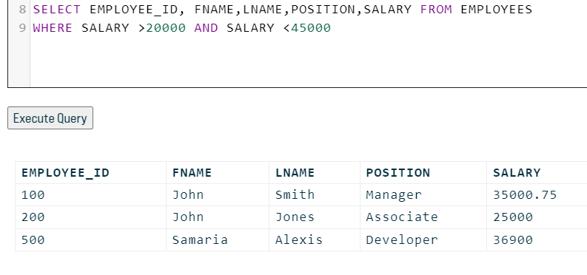

**PART B**

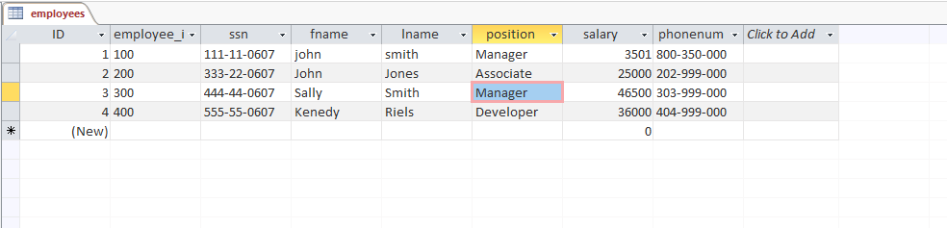

**TASK 3**

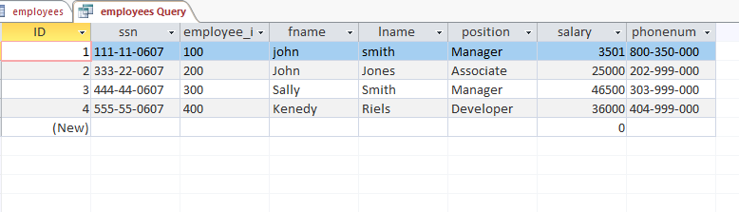

**TASK 4**

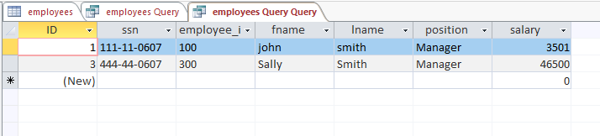

**TASK 5**

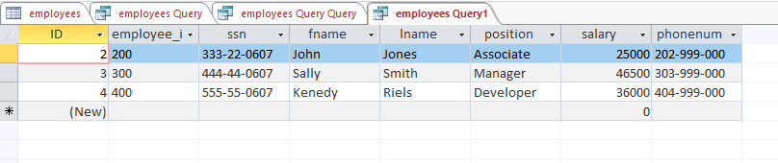

**TASK 6**

